Customer Requirements Specification

**Speed Bump WEB**

**ـــــــــــــــــــــــــــــــــــــــــــــــــــــــــــــــــــــــــــــــــــــــــــــــــــــــــــــــــــــــــــــــــــــــــــــــــــــــــــــــــــــــــــــــــــــــــــــــــــــــــــــــــــــــــــــــــــــــــــــــــــــــ**

**Table of Contents**

Document Status: ………………………………………………………………...1

Document History: ………………………………………………………………..1

Reference Document: …………………………………………………………....1

Project Description: ……………………………………………………………....2

# **Document Status:**

|  |  |
| --- | --- |
| **Name** | PO_SB_CRS_WEB |
| **Version** | V1.0 |
| **Status** | proposed |
| **Author** | Ahmed Mohamed |
| **Date** | [29-10-2022] |

## Document History:

|  |  |  |  |
| --- | --- | --- | --- |
| **Version** | **Author** | **Date** | **Change** |
| 1.0 | Ahmed Mohamed | [29-10-2022] | Initial Creation |

### Reference Document:

|  |  |  |  |
| --- | --- | --- | --- |
| **Ref.number** | **Doc.Name** | **Version** | **Status** |
| 1 | PO_SB_CR_WEB | V1.1 | Released |

#### 

#### Project Description:

Definition:

The website for customers to purchase the speed bump detector device, and dashboard for the admin users to control the web site.

Features:

* E-commerce for a customer to buy the device.
* Dashboard for an admin to control the website.

Key Elements:

* Customer shall have an account.
* The E-commerce website shall contain a landing page shows features about the product.
* Customer shall be able to place and track the device.
* Customer shall be able to send feedback.
* Dashboard users shall have different roles.
* Dashboard roles shall have different permissions.
* On dashboard each admin user shall have an account.
* Dashboard shall contain page to display all users who are using the mobile application and/or the device.
* Dashboard shall contain page to show all sold devices’ Info.
* Dashboard shall contain page to show users’ feedback.

System Context:

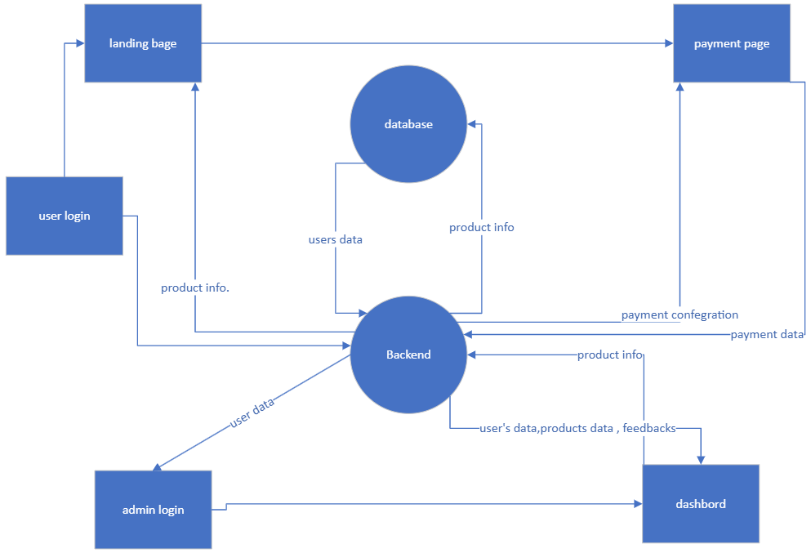

CRS Requirements:

|  |  |  |  |
| --- | --- | --- | --- |
| **Req_ID** | PO_SB_CRS_**001**-V1.0 | **Covers** | PO_SB_CR_WEB**_001**-V1.0 |
| **Description** | The user shall register on the website if he is entering for the first time. | | |

|  |  |  |  |
| --- | --- | --- | --- |
| **Req_ID** | PO_SB_CRS_**002**-V1.0 | **Covers** | PO_SB_CR_WEB**_001**-V1.0 |
| **Description** | The user shall login if he has an account. | | |
| **Req_ID** | PO_SB_CRS_**003**-V1.0 | **Covers** | PO_SB_CR_WEB**_001**-V1.0 |
| **Description** | The user can login through (Facebook or Google email). | | |
| **Req_ID** | PO_SB_CRS_**004**-V1.0 | **Covers** | PO_SB_CR_WEB**_001**-V1.0 |
| **Description** | On the login page, the customer can reset their password. | | |
| **Req_ID** | PO_SB_CRS_**005**-V1.0 | **Covers** | PO_SB_CR_WEB**_002**-V1.0 |
| **Description** | When the user login the site, he will find a page that displays information about the device. | | |
| **Req_ID** | PO_SB_CRS_**006**-V1.0 | **Covers** | PO_SB_CR_WEB**_002**-V1.0 |
| **Description** | On the landing page, the customer can buy the device. | | |
| **Req_ID** | PO_SB_CRS_**007**-V1.0 | **Covers** | PO_SB_CR_WEB**_002**-V1.0 |
| **Description** | On the landing page, the customer can contact us. | | |
| **Req_ID** | PO_SB_CRS_**008**-V1.0 | **Covers** | PO_SB_CR_WEB**_003**-V1.0 |
| **Description** | When the customer clicks on the purchase button, he will be transferred to the page for ordering the device. | | |
| **Req_ID** | PO_SB_CRS_**009**-V1.0 | **Covers** | PO_SB_CR_WEB**_003**-V1.0 |
| **Description** | Upon completion of filling in the details of the purchase, confirming the payment, the device will be reserved. | | |
| **Req_ID** | PO_SB_CRS_**0010**-V1.0 | **Covers** | PO_SB_CR_WEB**_003**-V1.0 |
| **Description** | Customer can track their order. | | |
| **Req_ID** | PO_SB_CRS_**0011**-V1.0 | **Covers** | PO_SB_CR_WEB**_004**-V1.0 |
| **Description** | The customer can send feedback about the device. | | |
| **Req_ID** | PO_SB_CRS_**0012**-V1.0 | **Covers** | PO_SB_CR_WEB**_004**-V1.0 |
| **Description** | The customer can contact us in the event of a device malfunction. | | |
| **Req_ID** | PO_SB_CRS_**0013**-V1.0 | **Covers** | PO_SB_CR_WEB**_005**-V1.0 |
| **Description** | There will be different rules for entering the Dashboard (admin, super admin). | | |
| **Req_ID** | PO_SB_CRS_**0014**-V1.0 | **Covers** | PO_SB_CR_WEB**_00**6-V1.0 |
| **Description** | There will be different permissions on the Dashboard. | | |
| **Req_ID** | PO_SB_CRS_**0015**-V1.0 | **Covers** | PO_SB_CR_WEB**_006**-V1.0 |
| **Description** | a super admin can see everything in dashboard and adding admins or removing them. | | |
| **Req_ID** | PO_SB_CRS_**0016**-V1.0 | **Covers** | PO_SB_CR_WEB**_00**6-V1.0 |
| **Description** | The super admin can enter the devices available for sale. | | |
| **Req_ID** | PO_SB_CRS_**0017**-V1.0 | **Covers** | PO_SB_CR_WEB**_006**-V1.0 |
| **Description** | An admin can only view some pages. | | |
| **Req_ID** | PO_SB_CRS_**0018**-V1.0 | **Covers** | PO_SB_CR_WEB**_007**-V1.0 |
| **Description** | Each admin shall have a different account to control a dashboard. | | |
| **Req_ID** | PO_SB_CRS_**0019**-V1.0 | **Covers** | PO_SB_CR_WEB**_008**-V1.0 |
| **Description** | The dashboard contains a page to display all users using the mobile application and/or device. | | |
| **Req_ID** | PO_SB_CRS_**0020**-V1.0 | **Covers** | PO_SB_CR_WEB**_00**9-V1.0 |
| **Description** | The dashboard contains a page to display information about all devices sold and their users. | | |
| **Req_ID** | PO_SB_CRS_**0021**-V1.0 | **Covers** | PO_SB_CR_WEB**_00**9-V1.0 |
| **Description** | The dashboard should contain a page to show the information of all the devices available for sale. | | |
| **Req_ID** | PO_SB_CRS_**0022**-V1.0 | **Covers** | PO_SB_CR_WEB**_00**10-V1.0 |
| **Description** | Dashboard shall contain page to show users’ feedback, and he can answer them. | | |